ITC Infotech Interview Question- Written Test (09-Sep-2017) – Gangadhar Reddy Batch 1

Jenkins

1)What is the difference between Continuous Delivery and Continuous Deployment in Jenkins?

Ans)

How can you use Jenkins CLI?

Ans)

Which plugin used for code coverage in Jenkins?

Ans) jacoco plug-in

Python

1. **What is the largest value in Integer type in Python 2.7?**

Ans) sys.maxsize

9223372036854775807

type(sys.maxsize)

<type 'int'> type(sys.maxsize+1)

<type 'long'>

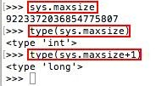

Explanation

For integers we have maxint and maxsize:

The maximum value of an int can be found in Python 2.x with sys.maxint. It was removed in Python 3, but sys.maxsize can often be used instead.

Python 3 does not have upper or lower limits on integers.

Float max value

>>> sys.float_info

sys.float_info(max=1.7976931348623157e+308, max_exp=1024, max_10_exp=308, min=2.2250738585072014e-308, min_exp=-1021, min_10_exp=-307, dig=15, mant_dig=53, epsilon=2.220446049250313e-16, radix=2, rounds=1)

>>>

Specifically, sys.float_info.max

>>>sys.float_info.max

>>> sys.float_info.max 1.7976931348623157e+308

>>>

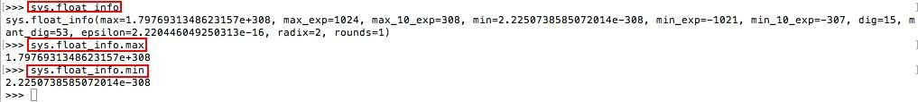

1. **How documenting a function in python 2.7?**

Ans) The pydoc module automatically generates documentation from Python modules. The documentation can be presented as pages of text on the console, served to a Web browser, or saved to HTML files.

For modules, classes, functions and methods, the displayed documentation is derived from the docstring (i.e. the __doc__ attribute) of the object, and recursively of its documentable members. If there is no docstring, pydoc tries to obtain a description from the block of comment lines just above the definition of the class, function or method in the source file, or at the top of the module (see inspect.getcomments()).

1. **Lambda**
2. **Regular Expression**
3. **Find the output of the below program.**

x,y=1,1

def f(); global x; y=0;

for I in (10,20,30); x+=1;

y+=I; f();

print x,y;

Output:

Linux and Cloud

====================================================================

Infosys Interview Questions- F2F (14-Sep-2017) – Gangadhar Reddy Batch 1

* 1. **As a DevOps Engineer, what are your day2day activities?**
  2. **Explain how can you installed plugins and customized plugins?**
  3. **Explain DevOps workflow?**
  4. **What is Distributed Version Control System?**
  5. **How can you do Security Management in Jenkins?**
  6. **Is Jenkins a standalone or master-slave?**
  7. **Are you created any pipeline jobs?**
  8. **How can you install customized plugins?**
  9. **Explain any branching strategies you’ve followed in GitHub?**
  10. **How can you work on UCD like configurations and all?**
  11. **Explain your roles and responsibilities in Tomcat?**
  12. **Explain how can you deploy an application into Bluemix?**
  13. **How can you debug logs in case of build failure?**
  14. **What is the difference between Regions and Availabilityzones?**
  15. **Is it mandatory to use GitHub? Why can I use Git instead of other VCS?**
  16. **Is can you use any special mechanisms for Testing?**
  17. **How can you write and use JUnit test cases?**
  18. **Can you perform any pre-build actions?**
  19. **How can you change Jenkins port number?**
  20. **What is the difference between Git Pull and Git Push?**
  21. **Write Shell Script for below scenario?**

One directory having a file. Check the status of the file, if it is available then moves it to target directory and print as “File Moved”. If it is not available then create new file?

Thank you for using [www.freepdfconvert.com](http://www.freepdfconvert.com/) service!

Only two pages are converted. Please Sign Up to convert all pages. <https://www.freepdfconvert.com/membership>